MBAI 5400G STORYBOARD ASSIGNMENT

Taiwo Judith Oyafajo 100984464

[Taiwo.Oyafajo@ontariotechu.ca](mailto:Taiwo.Oyafajo@ontariotechu.ca) 1st of October, 2024

**Video Game Sales Analysis Storyboard Reflection**

For this assignment, Dr. Gabby has asked that we prepare a storyboard for a human-centred data story on a relevant topic.

As an IT Business Analyst, I’ve decided to pivot towards data analytics because I find the process of creating reports both fascinating and rewarding. To prepare for my upcoming Master’s program, I began self-learning by exploring different datasets and collaborating with peers in the field. One of the first datasets I chose to work on was “Sales Analysis in the Gaming Industry,” a subject I’m particularly drawn to due to my interest in gaming.

For this assignment, I chose to analyze video game sales. My main objectives were to identify emerging trends, assess consumer preferences, and pinpoint opportunities and successes within the gaming industry, particularly focusing on the addictive nature of games, especially among male players. The dataset, which I sourced from Kaggle, includes various details such as game titles, rankings, platforms, release years, genres, publishers, sales figures across four regions, and global sales totals.

The first iteration of this assignment is from Miro a collaboration tool, to establish the context and framework for my video game sales analysis. This helped me organize my thoughts and approach the data systematically.

In the second iteration of my project, I developed a storyboard using my sketchbook to illustrate how video game sales have declined due to the rise of digitalization. The focus was on how gaming enthusiasts transitioned from purchasing games in physical stores to opting for digital downloads, resulting in a decrease in traditional sales. Game sellers needed to analyze sales datasets to understand the cause of this revenue decline, comparing it against various sales data.

For the third iteration, I created a more refined storyboard using Google Slides, closely following the format of the previous version but incorporating visuals and graphs to emphasize the theme—video game sales analysis. This version also identified key players, such as gamers, enthusiasts, and the broader gaming community. I provided details about the data source, Kaggle.com, and explained why bar charts were used as the primary visualization tool to represent the data. The final deliverable will be presented through an interactive dashboard for a more dynamic exploration of the insights.

Iteration 1

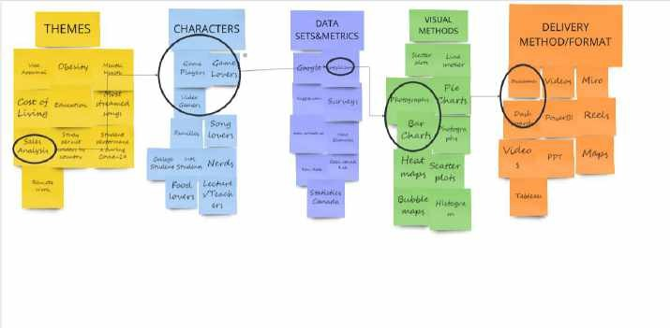

Iteration 2

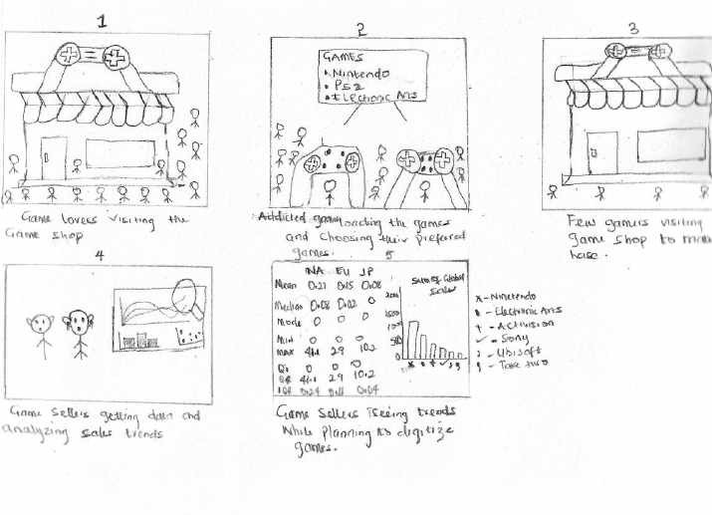

Iteration 3





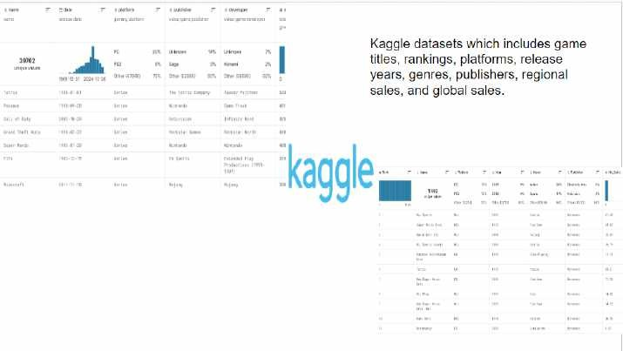

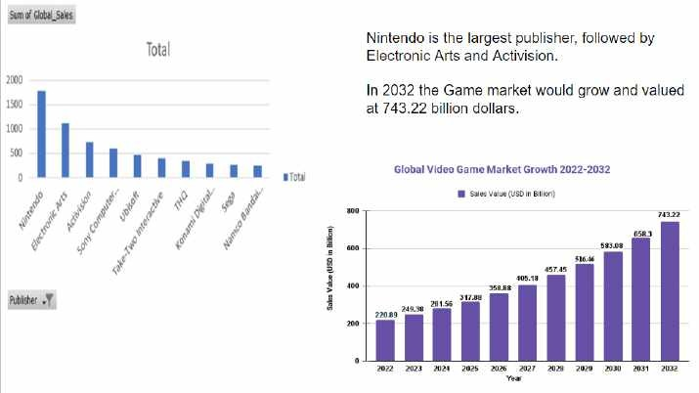

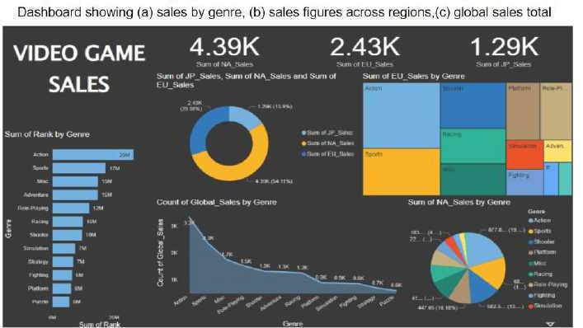

References and Images

* <https://www.kaggle.com/datasets>
* [https://www.google.ca/search?q=photograph+showing+game+sales+analysis+&sca_esv=](https://www.google.ca/search?q=photograph%2Bshowing%2Bgame%2Bsales%2Banalysis%2B&sca_esv=c95792980f3c473c&sca_upv=1&biw=1536&bih=695&udm=2&sxsrf=ADLYWILgmvRYyetBjJVrOFfxO5YbdW1fbA%3A1727831463114&ei=p538ZqrRBoGnptQPsJjaqAU&ved=0ahUKEwjqwNzkwe6IAxWBk4kEHTCMFlUQ4dUDCBA&uact=5&oq=photograph%2Bshowing%2Bgame%2Bsales%2Banalysis%2B&gs_lp=Egxnd3Mtd2l6LXNlcnAiJ3Bob3RvZ3JhcGggc2hvd2luZyBnYW1lIHNhbGVzIGFuYWx5c2lzIEieB1D5BFj5BHABeACQAQCYAUCgAUCqAQExuAEDyAEA-AEBmAIAoAIAmAMAiAYBkgcAoAc1&sclient=gws-wiz-serp) [c95792980f3c473c&sca_upv=1&biw=1536&bih=695&udm=2&sxsrf=ADLYWILgmvR](https://www.google.ca/search?q=photograph%2Bshowing%2Bgame%2Bsales%2Banalysis%2B&sca_esv=c95792980f3c473c&sca_upv=1&biw=1536&bih=695&udm=2&sxsrf=ADLYWILgmvRYyetBjJVrOFfxO5YbdW1fbA%3A1727831463114&ei=p538ZqrRBoGnptQPsJjaqAU&ved=0ahUKEwjqwNzkwe6IAxWBk4kEHTCMFlUQ4dUDCBA&uact=5&oq=photograph%2Bshowing%2Bgame%2Bsales%2Banalysis%2B&gs_lp=Egxnd3Mtd2l6LXNlcnAiJ3Bob3RvZ3JhcGggc2hvd2luZyBnYW1lIHNhbGVzIGFuYWx5c2lzIEieB1D5BFj5BHABeACQAQCYAUCgAUCqAQExuAEDyAEA-AEBmAIAoAIAmAMAiAYBkgcAoAc1&sclient=gws-wiz-serp) [YyetBjJVrOFfxO5YbdW1fbA%3A1727831463114&ei=p538ZqrRBoGnptQPsJjaqAU&](https://www.google.ca/search?q=photograph%2Bshowing%2Bgame%2Bsales%2Banalysis%2B&sca_esv=c95792980f3c473c&sca_upv=1&biw=1536&bih=695&udm=2&sxsrf=ADLYWILgmvRYyetBjJVrOFfxO5YbdW1fbA%3A1727831463114&ei=p538ZqrRBoGnptQPsJjaqAU&ved=0ahUKEwjqwNzkwe6IAxWBk4kEHTCMFlUQ4dUDCBA&uact=5&oq=photograph%2Bshowing%2Bgame%2Bsales%2Banalysis%2B&gs_lp=Egxnd3Mtd2l6LXNlcnAiJ3Bob3RvZ3JhcGggc2hvd2luZyBnYW1lIHNhbGVzIGFuYWx5c2lzIEieB1D5BFj5BHABeACQAQCYAUCgAUCqAQExuAEDyAEA-AEBmAIAoAIAmAMAiAYBkgcAoAc1&sclient=gws-wiz-serp) [ved=0ahUKEwjqwNzkwe6IAxWBk4kEHTCMFlUQ4dUDCBA&uact=5&oq=photograp](https://www.google.ca/search?q=photograph%2Bshowing%2Bgame%2Bsales%2Banalysis%2B&sca_esv=c95792980f3c473c&sca_upv=1&biw=1536&bih=695&udm=2&sxsrf=ADLYWILgmvRYyetBjJVrOFfxO5YbdW1fbA%3A1727831463114&ei=p538ZqrRBoGnptQPsJjaqAU&ved=0ahUKEwjqwNzkwe6IAxWBk4kEHTCMFlUQ4dUDCBA&uact=5&oq=photograph%2Bshowing%2Bgame%2Bsales%2Banalysis%2B&gs_lp=Egxnd3Mtd2l6LXNlcnAiJ3Bob3RvZ3JhcGggc2hvd2luZyBnYW1lIHNhbGVzIGFuYWx5c2lzIEieB1D5BFj5BHABeACQAQCYAUCgAUCqAQExuAEDyAEA-AEBmAIAoAIAmAMAiAYBkgcAoAc1&sclient=gws-wiz-serp) [h+showing+game+sales+analysis+&gs_lp=Egxnd3Mtd2l6LXNlcnAiJ3Bob3RvZ3JhcGg](https://www.google.ca/search?q=photograph%2Bshowing%2Bgame%2Bsales%2Banalysis%2B&sca_esv=c95792980f3c473c&sca_upv=1&biw=1536&bih=695&udm=2&sxsrf=ADLYWILgmvRYyetBjJVrOFfxO5YbdW1fbA%3A1727831463114&ei=p538ZqrRBoGnptQPsJjaqAU&ved=0ahUKEwjqwNzkwe6IAxWBk4kEHTCMFlUQ4dUDCBA&uact=5&oq=photograph%2Bshowing%2Bgame%2Bsales%2Banalysis%2B&gs_lp=Egxnd3Mtd2l6LXNlcnAiJ3Bob3RvZ3JhcGggc2hvd2luZyBnYW1lIHNhbGVzIGFuYWx5c2lzIEieB1D5BFj5BHABeACQAQCYAUCgAUCqAQExuAEDyAEA-AEBmAIAoAIAmAMAiAYBkgcAoAc1&sclient=gws-wiz-serp) [gc2hvd2luZyBnYW1lIHNhbGVzIGFuYWx5c2lzIEieB1D5BFj5BHABeACQAQCYAU](https://www.google.ca/search?q=photograph%2Bshowing%2Bgame%2Bsales%2Banalysis%2B&sca_esv=c95792980f3c473c&sca_upv=1&biw=1536&bih=695&udm=2&sxsrf=ADLYWILgmvRYyetBjJVrOFfxO5YbdW1fbA%3A1727831463114&ei=p538ZqrRBoGnptQPsJjaqAU&ved=0ahUKEwjqwNzkwe6IAxWBk4kEHTCMFlUQ4dUDCBA&uact=5&oq=photograph%2Bshowing%2Bgame%2Bsales%2Banalysis%2B&gs_lp=Egxnd3Mtd2l6LXNlcnAiJ3Bob3RvZ3JhcGggc2hvd2luZyBnYW1lIHNhbGVzIGFuYWx5c2lzIEieB1D5BFj5BHABeACQAQCYAUCgAUCqAQExuAEDyAEA-AEBmAIAoAIAmAMAiAYBkgcAoAc1&sclient=gws-wiz-serp) [CgAUCqAQExuAEDyAEA-AEBmAIAoAIAmAMAiAYBkgcAoAc1&sclient=gws-](https://www.google.ca/search?q=photograph%2Bshowing%2Bgame%2Bsales%2Banalysis%2B&sca_esv=c95792980f3c473c&sca_upv=1&biw=1536&bih=695&udm=2&sxsrf=ADLYWILgmvRYyetBjJVrOFfxO5YbdW1fbA%3A1727831463114&ei=p538ZqrRBoGnptQPsJjaqAU&ved=0ahUKEwjqwNzkwe6IAxWBk4kEHTCMFlUQ4dUDCBA&uact=5&oq=photograph%2Bshowing%2Bgame%2Bsales%2Banalysis%2B&gs_lp=Egxnd3Mtd2l6LXNlcnAiJ3Bob3RvZ3JhcGggc2hvd2luZyBnYW1lIHNhbGVzIGFuYWx5c2lzIEieB1D5BFj5BHABeACQAQCYAUCgAUCqAQExuAEDyAEA-AEBmAIAoAIAmAMAiAYBkgcAoAc1&sclient=gws-wiz-serp) [wiz-serp](https://www.google.ca/search?q=photograph%2Bshowing%2Bgame%2Bsales%2Banalysis%2B&sca_esv=c95792980f3c473c&sca_upv=1&biw=1536&bih=695&udm=2&sxsrf=ADLYWILgmvRYyetBjJVrOFfxO5YbdW1fbA%3A1727831463114&ei=p538ZqrRBoGnptQPsJjaqAU&ved=0ahUKEwjqwNzkwe6IAxWBk4kEHTCMFlUQ4dUDCBA&uact=5&oq=photograph%2Bshowing%2Bgame%2Bsales%2Banalysis%2B&gs_lp=Egxnd3Mtd2l6LXNlcnAiJ3Bob3RvZ3JhcGggc2hvd2luZyBnYW1lIHNhbGVzIGFuYWx5c2lzIEieB1D5BFj5BHABeACQAQCYAUCgAUCqAQExuAEDyAEA-AEBmAIAoAIAmAMAiAYBkgcAoAc1&sclient=gws-wiz-serp)
* [https://towardsdatascience.com/data-analysis-project-game-sales-interactive-dashboard-](https://towardsdatascience.com/data-analysis-project-game-sales-interactive-dashboard-323dcef7dd47) [323dcef7dd47](https://towardsdatascience.com/data-analysis-project-game-sales-interactive-dashboard-323dcef7dd47)
* [https://www.linkedin.com/pulse/video-game-market-focus-revenue-swot-analysis-up-](https://www.linkedin.com/pulse/video-game-market-focus-revenue-swot-analysis-up-2032-rachel-duffy/) [2032-rachel-duffy/](https://www.linkedin.com/pulse/video-game-market-focus-revenue-swot-analysis-up-2032-rachel-duffy/)
* [https://www.enterpriseappstoday.com/news/video-game-market-size-220-89-bn-and-](https://www.enterpriseappstoday.com/news/video-game-market-size-220-89-bn-and-opportunities-by-2032-analysis-on-impact-of-us-crises.html#google_vignette) [opportunities-by-2032-analysis-on-impact-of-us-crises.html#google_vignette](https://www.enterpriseappstoday.com/news/video-game-market-size-220-89-bn-and-opportunities-by-2032-analysis-on-impact-of-us-crises.html#google_vignette)
* [https://studentwork.prattsi.org/infovis/visualization/visualizing-video-game-data-2007-](https://studentwork.prattsi.org/infovis/visualization/visualizing-video-game-data-2007-2016-with-tableau/) [2016-with-tableau/](https://studentwork.prattsi.org/infovis/visualization/visualizing-video-game-data-2007-2016-with-tableau/)